Guidelines for Abstract Preparation of ICPS2026 Heterostructures

(Bold, 12 point, Times or Times New Roman)

K. Hirakawa^{1*}, S. Tarucha², H. Ohno³, and Y. Arakawa¹ (11 point, Times or Times New Roman)
¹ Institute of Industrial Science, The University of Tokyo, 4-6-1 Komaba, Meguro-ku, Tokyo, 153-8505, Japan (11 point, Italic, Times or Times New Roman)
² Center for Emergent Matter Science, RIKEN, 2-1 Hirosawa, Wako, Saitama, 351-0198, Japan (11 point, Italic, Times or Times New Roman)
³ Research Institute of Electrical Communication, Tohoku University, 2-1-1 Katahira, Aoba-ku, Sendai, Miyagi, Japan 980-8577, Japan (11 point, Italic, Times or Times New Roman)
*hirakawa@iis.u-tokyo.ac.jp (11 point, Times or Times New Roman)r
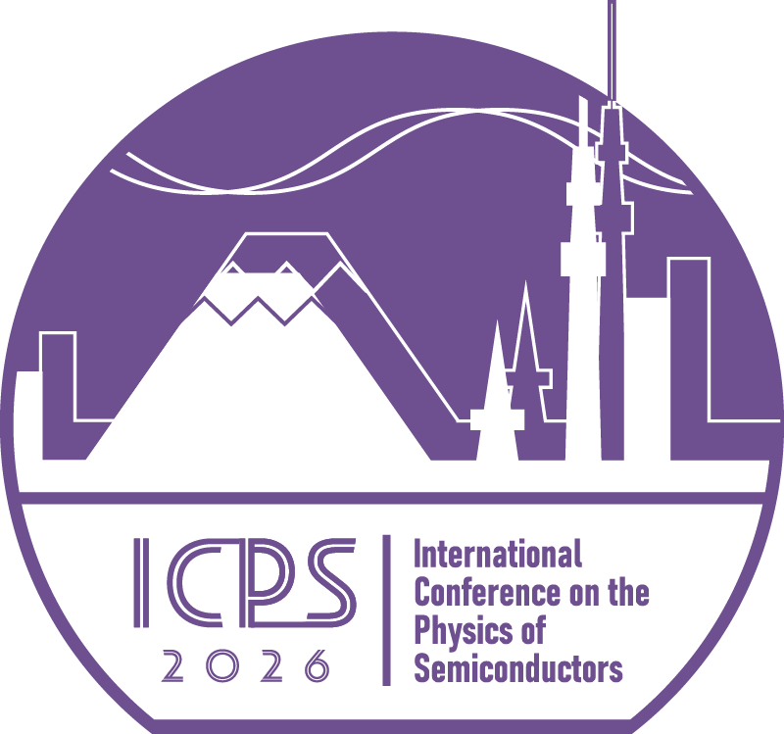
A camera-ready one-page abstract should be prepared on an A4-size paper with 2 cm margins all around and uploaded in the pdf format. The abstract must include the title of the paper, author(s), affiliation(s), address(es) and e-mail address of the corresponding author. In the title, use capital letters for the initial letter of each word except articles, prepositions and conjunctions. Place a blank line between the title and author(s). The main text should be typed with single-spaced and 11 point. The numbered list of all references should be at the end of the abstract. When referring to them in the text, the reference number should be indicated by brackets, such as [1,2]. Figures can be included; they should be numbered consecutively and accompanied by a figure caption in 10 point below the figure. Please do not generate page numbers. The submission deadline is 15 March, 2026.
Fig. 1. ICPS2026 logo (10 point)
When uploading your abstract, you may incicate your preference for an oral or a poster presentation. Furthermore, please specify the tentative speaker/presenter and the category which is most appropriate for your contribution:
1. Material growth, structural properties and characterization
2. Wide-bandgap semiconductors
3. Semiconductors for terahertz and mid infrared
4. Graphene, 2D materials
5. Halide perovskites and organic semiconductors
6. Topological states of matter
7. Spintronics, spin-related phenomena, novel spintronics materials and devices
8. Low dimensional semiconductor systems
9. Quantum Hall effect, fractional quantum Hall effect
10. Optical properties of quantum dots and nanocrystals, optoelectronics
11. Nanophotonics
12. Quantum optics, quantum emitters, NV centers
13. Quantum technologies: semiconductor qubits and applications, cryo-CMOS technologies
14. Semiconductor hybrid systems, nano-mechanics, novel devices

References
[1] Y. Arakawa and H. Sakaki, Appl. Phys. Lett. 40, 939 (1982).
[2] S. Tarucha, D. G. Austing, T. Honda, R. J. van der Hage and L. P. Kouwenhoven, Phys. Rev. Lett. 77, 3613 (1996).

